Introduction to HTML (Continued.)
LAB # 08


Spring 2022
Computer Fundamental

Submitted by: Muhammad Sadeeq
Registration No : 21PWCSE2028
Class Section: C

“On my honor, as student of University of Engineering and Technology, I have neither given nor received unauthorized assistance on this academic work.”

Student Signature: _Muhammad Sadeeq__

Submitted to:
Engr. Abdullah Hamid
(13-March-2022)

Department of Computer Systems Engineering
University of Engineering and Technology, Peshawar

Lab 8:
Introduction to HTML (Continued.)
Lab Tasks:
- Create an HTML webpage with Title “DCSE” and UET logo as a favicon. Everything on this page must be aligned to center. Also include a heading called MY DCSE Profile. Create a list underneath it that contains points like name, registration number, section, semester, lab name and finally last point skills, skills should have nested list containing your skills.
- After the list leave some space and create subheading “My Classes Schedule” after this Create a Table in HTML Shown Below.
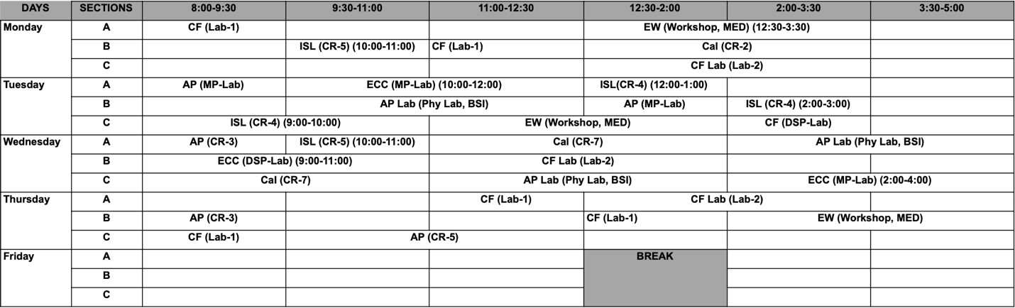

HTML OUTPUT
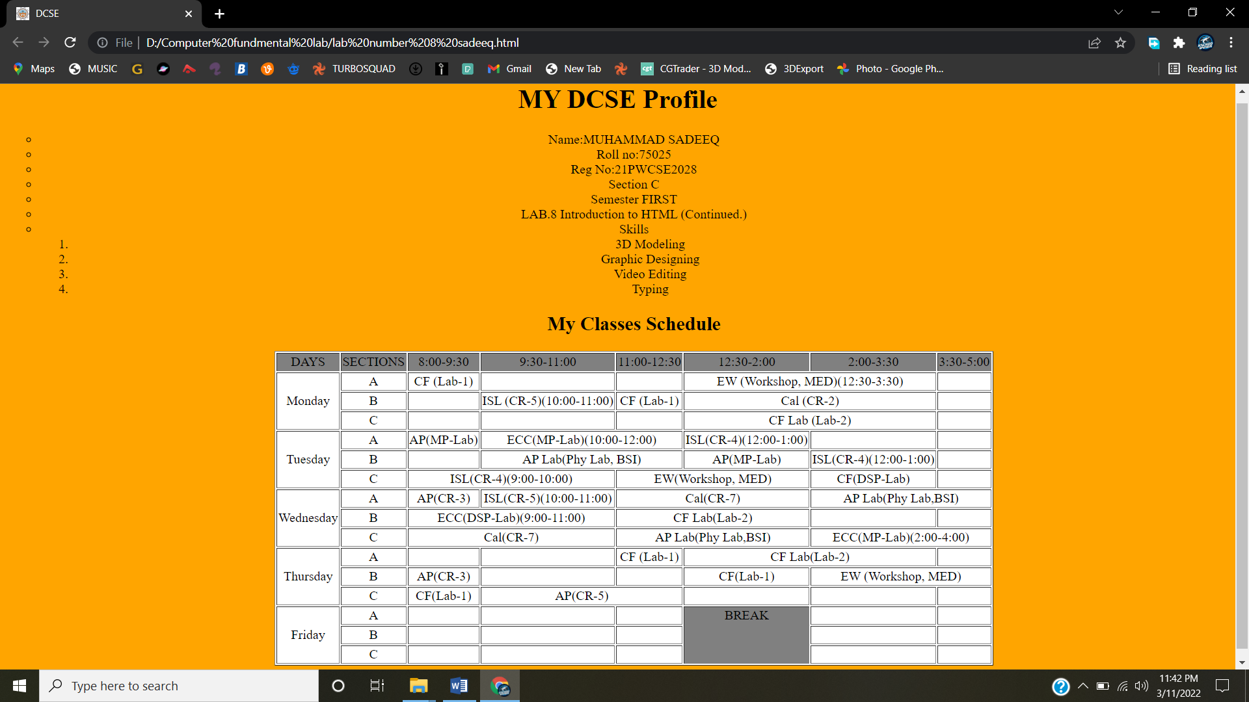
HTML CODE
